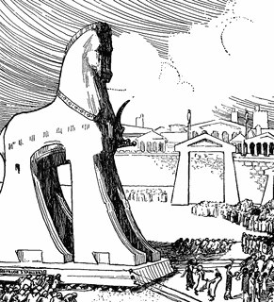

WEEK ONE

1. Today we are placing six timeline images.
– Cut out the images in your baggie.
– Cut apart the statements.
2. Above the line on each page, paste the following images at these dates:
On p. 25 = 1200-1101 BC
–Paste “01 Trojan” image at 1200BC

p. 27 = 1100-1001 BC
–Paste “02 David” at 1050

p. 35 = 700-601 BC
–Paste “04 Lycurgus” at 630

p. 37 = 600-501 BC
–Paste “05 Nebuchadne” at 586
–Paste “06 Temple” at 515
p. 39 = 500-401 BC
–Paste “10 parthenon” at 438

3. Below the lines, paste/write the corresponding statements from pages 123-124 of DYOCC for each figure you placed.

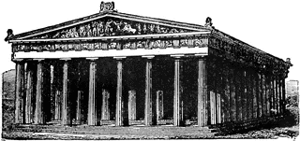

WEEK FOUR

1. Today we are placing three timeline images.
– Cut out the images in your baggie.
– Cut apart the statements.
2. Above the line on each page, paste the following images at these dates:
p. 39 = 500-401 BC
–Paste “09 Marathon” at 490
–Paste “10 Thermopylae” at 479
–Paste “11 peloponnesian” at 404
3. Below the lines, paste/write the corresponding statements from pages 123-124 of DYOCC for each figure you placed.

WEEK SIX

1. Today we are placing three timeline images.
– Cut out the images in your baggie.
– Cut apart the statements.
2. Above the line on each page, paste the following images at these dates:
p. 39 = 500-401 BC
–Paste “12 xenophon” at 401
p. 41 = 400-301 BC
–Paste “13 socrates” at 399
–Paste “15 alexander” at 336
–Paste “14 sack rome” at 390

p. 43 = 300-201 BC
–Paste “16 euclid” at 300

3. Below the lines, paste/write the corresponding statements from pages 123-124 of DYOCC for each figure you placed.

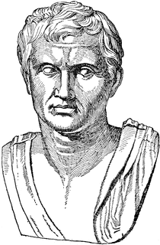

WEEK SIXTEEN

1. Today we are placing six timeline images.
– Cut out the images in your baggie.
– Cut apart the statements.
2. Above the line on each page, paste the following images at these dates:
p. 33 = 800-701 BC
–Paste “03 Romulus” at 753
–Paste “7 Tarquin” at 509

p. 43 = 300-201 BC
–Paste “17 hannibal” at 202

p. 45 = 200-101 BC
–Paste “18 maccabees” at 160
–Paste “19 gracchus” at 133

3. Below the lines, paste/write the corresponding statements from pages 123-124 of DYOCC for each figure you placed.

WEEK EIGHTEEN

1. Today we are placing five timeline images.
– Cut out the images in your baggie.
– Cut apart the statements.
2. Above the line on each page, paste the following images at these dates:
p. 55 = 300-399 AD
–Paste “14 sack rome” at 390

p. 47 = 100-1 BC
–Paste “20 pompey” at 60
–Paste “21 julius” at 44
–Paste “22 octavius” at 31
–Paste “23 augustus” at 23

3. Below the lines, paste/write the corresponding statements from pages 123-124 of DYOCC for each figure you placed.

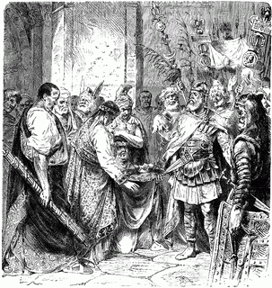

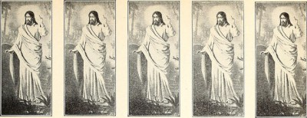

WEEK TWENTY-SEVEN

1. Today we are placing eight timeline images.
– Cut out the images in your baggie.
– Cut apart the statements.
2. Above the line on each page, paste the following images at these dates:
p. 49 = 0-99 AD
–Paste “ 24 our lord” at 29

p. 51 = 100-199 AD
–Paste “25 hadrian” at 123

p. 55 = 300-399 AD
–Paste “26 constantine” at 313
–Paste “27 diocletian divides” at 395

p. 57 = 400-499 AD
–Paste “28 staugustine” at 430
–Paste “29 rome fall” at 476

3. Below the lines, paste/write the corresponding statements from pages 123-124 of DYOCC for each figure you placed.

