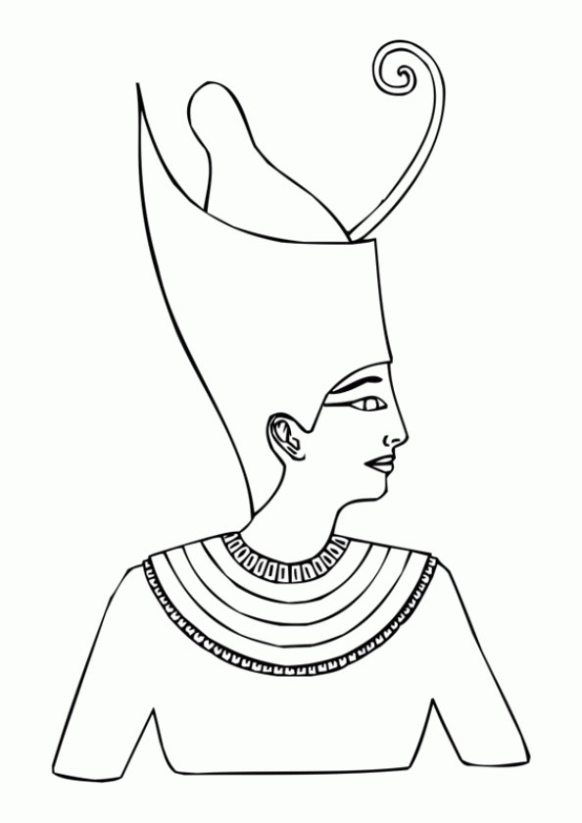

DAY ONE
1. Set up your book like I did in this post.
–Print out the Egypt images.
–Print out the “Timeline for Ancient Egypt” (or copy from your syllabus).
2. Put the lines on spread 7-8 an estimate some tickmarks for BABEL-2000 BC.
–Cut out the “Old Kingdom”, “First Intermediate”, Abraham, and “Middle Kingdom” statements from the “Timeline for Ancient Egypt”
–Also cut out the following figures: Menes, Sphinx, Pepi II, Abram, Mentuhotep II
*For the first day, I did all of the steps up to here. I put the images/instruction#3 in one baggie and the statements/instruction#4 in another.
3. Above the line, paste the following images at these dates:
–Place Menes at 2815, Pepi II at 2181.
–Pick a color for the old kingdom and shade the line between the two dates.
–Paste the sphinx somewhere in between.
–Paste Mentuhotep II at 2040.
–Pick a color for the 1st Intermediate Period and shade between him and Pepi II.
–Paste Abraham at 2100.
–Pick a color for the Middle Kingdom and shade from Mentuhotep to the end of the page.
4. Write/paste the statements below the line in the following order:
–Old Kingdom statement about Menes
–2181 Death of Pepi II, 6th dynasty and last good pharaoh of the period, begins the First Intermediate Period.
–First Intermediate Period statement.
–Abraham statement
–2040 Mentuhotep II, 11th dynasty, is the first good pharoah since Pepi II, begins Middle Kingdom.
–Middle Kingdom statement.

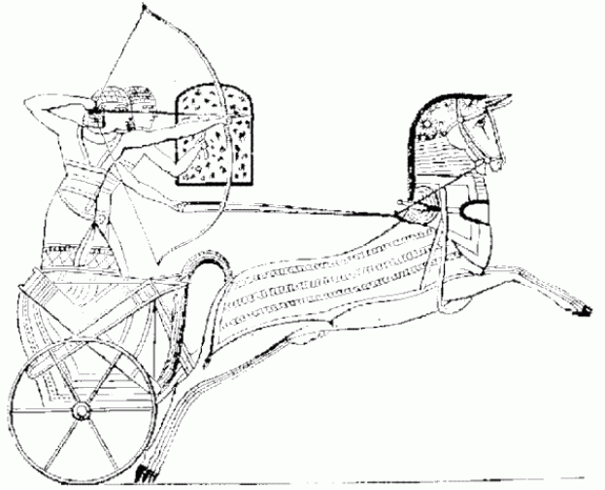

DAY TWO
1. Put the lines and tickmarks on spreads 11-12 (1900-1801), 13-14 (1800-1701), and 17-18 (1600-1501) of the timeline book. Put lines only on spreads 9-10, 15-16 (don’t need tickmarks today).
–Cut out the Joseph, “Second Intermediate Period”, Hittite and “New Kingdom” statements.
–Cut out Joseph, Hyksos, and Hittite images.
2. Above the line, paste the following images at these dates:
–Paste the Hyksos at 1786 on spread 13-14
–Color there all the way back to Mentuhotep II using the color you chose yesterday for the Middle Kingdom.
–Paste Joseph at 1898 on spread 11-12
–Paste the Hittites at 1576 on spread 17-18 (not sure this is where they really go, there’s no date.)
–Choose a color for the Second Intermediate Period and shade from the Hittites all the way back to Hyksos on 13-14.
–Choose a color for the New Kingdom and shade from the Hittites (or about 1570) to the end of the page.
3. Below the lines, paste/write the following statements:
–Joseph statement on spread 11-12
–Hyksos statement on spread 13-14
–Hittite statement on spread 17-18
–Place the “New Kingdom” statement below it.
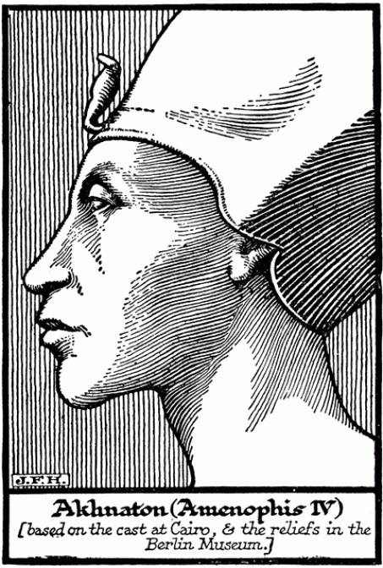

DAY THREE
1. Put the lines and tickmarks on spreads 19-20 (1500-1401) and 21-22 (1400-1301). Shade both lines the “New Kingdom” color you chose yesterday.
–Cut out Thutmose I, Queen Hatsheput, Thutmose II, Moses, Akhenaton, and Tutankhaman statements and images.
2. Above the line, paste the following images at these dates:
–Paste the Thutmose I at 1530 on spread 17-18
–Paste Hatsheput at 1505.
–Paste Thutmose II at 1480 on spread 19-20
–Paste Moses around 1450
–Paste Akhenaton at 1385 on spread 21-22
–Paste Tut at 1358
3. Below the lines, paste/write the following statements:
–Thutmose I and Hatsheput on spread 17-18
–Thutmose II and Moses on spread 19-20
–Akhenaton and Tut on spread 21-22
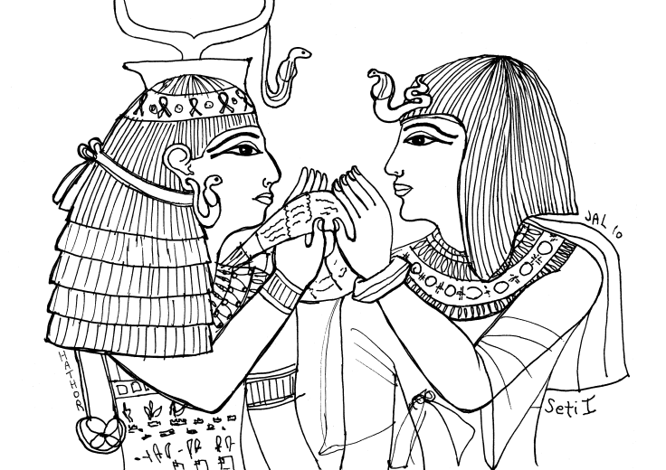

DAY FOUR
1. Put the lines and tickmarks on spreads 23-24 (1300-1201), 27-28 (1100-1001), 41-42 (400-301), 47-48 (100-1BC). Put lines on every empty spread from 25-26 to 45-46.
–Cut out Ramses I, Seti I, Ramses II images, Alexander, Ptolemy, Cleopatra
–Cut out statements for Ramses I/Seti I, Battle of Kadesh, Last Dynastic Period, Ptolemaic Dynasty.
2. Above the line, paste the following images at these dates:
–Paste the Rameses I at 1295 on spread 23-24
–Paste Seti I at 1290.
–Paste Rameses II at 1274
–Put a star (or other symbol) at 1085 on spread 27-28. Color back from there in the “New Kingdom” color to spread 21-22.
–Paste Alexander the Great at 332 on spread 41-42 . Choose a color for the Last Dynastic Period and color all the way back to the star on 27-28.
–Paste Ptolemy at 305.
–Paste Cleopatra at 30 BC on spread 47-48. Choose a color for the Ptolemaic Dynasty and color from here all the way back to Alexander on 41-42.
3. Below the lines, paste/write the following statements:
–Haremhab/Rameses I/Seti I statement on 23-24
–Battle of Kadesh too.
–“Last Dynastic” statement on 27-28
–“Ptolemaic Dynasty” statement on 41-42
–Write “Cleopatra dies. Egypt becomes province of Rome” on 47-48.

